**Introduction:**

Hemoglobin is actually the primary portion of red blood cells and bind Oxygen. Having a very few red blood cells or if the hemoglobin level is low in the body, the cells don’t get enough amount of oxygen. Anemia is one of the most common blood condition which is affecting a large number of patients around the globe. Anemia is caused because of one or more processes briefed as follows:

* Defectiveness in the formation of red blood cells because of diet lacking essential nutrients, deficiency of iron, or increased utilization of nutrients such as during pregnancy, lactation, or rapid menstrual cycles.
* Rapid number of red cell destruction because of parasitic conditions like malaria or sickle cell anemia (genetic condition) or thalassemia.
* Blood loss which is because of hookworm of large menstrual flow.

The common way to depict the state of Anemia is by measuring the hemoglobin of the patient. (Oxygen carrying component in red blood cells) or by estimating the hematocrit.

Following are some of the types of Anemia:

* Iron Deficiency anemia
* Thalassemia
* Aplastic Anemia
* Hemolytic Anemia
* Sickle Cell Anemia
* Pernicious Anemia
* Fanconi Anemia

The most commonly found type of anemia is Iron Deficiency Anemia. The normal range of Hemoglobin is:

**Normal Hemoglobin and Hematocrit Ranges**

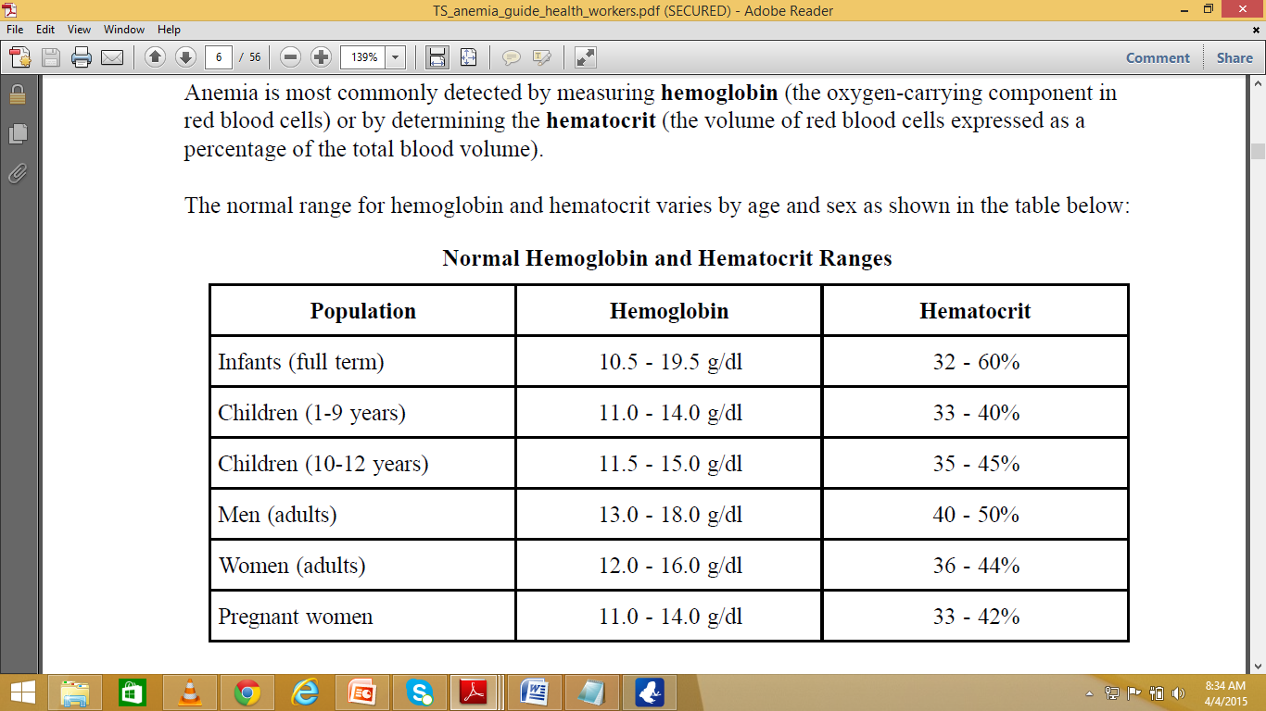

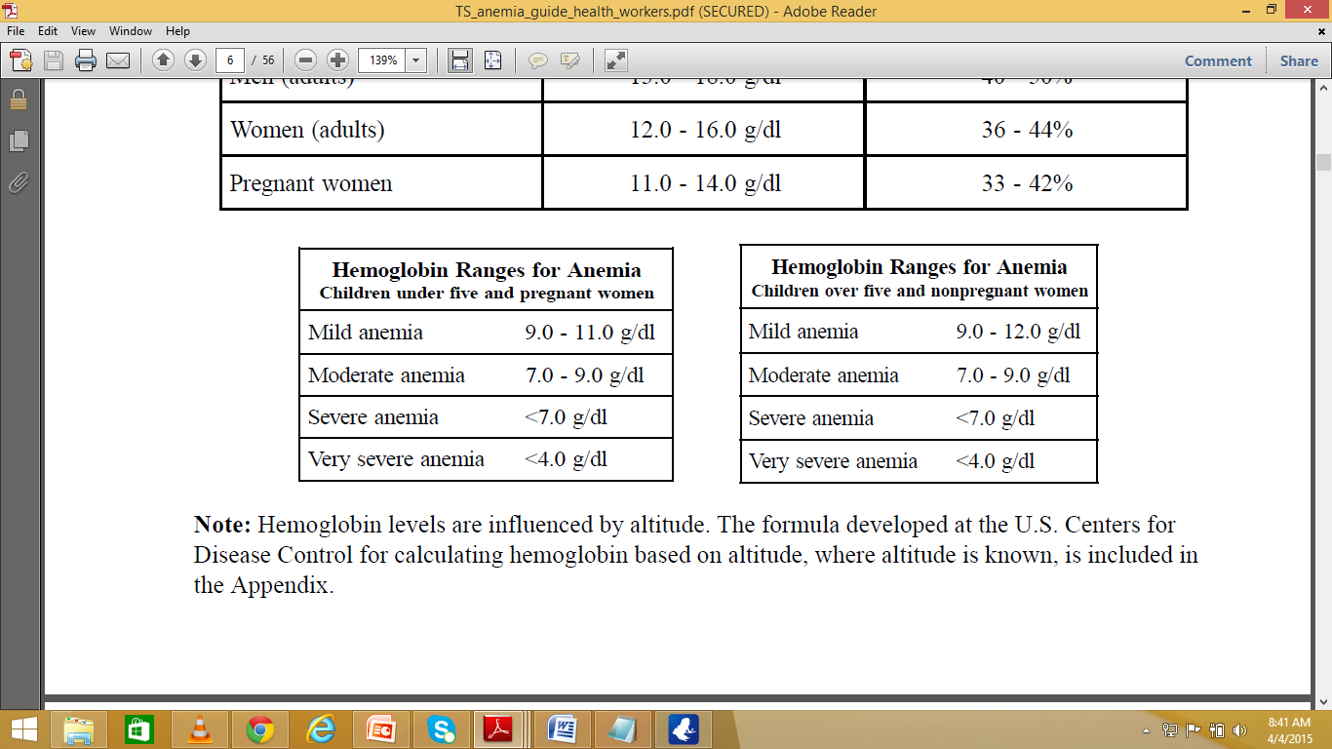

**Invasive Methods of measuring Hemoglobin:**

Some of the methods of measuring hemoglobin values from blood samples are as follows:

**Filter Paper Method:**

Red color in the blood can be illustrator as a pointer of the hemoglobin present in the body. Degree of Anemia can be visualized by matching the color of the blood on the filter paper with the standardized color chart. The color chart has been developed to represent the color range of normal to anemic blood on filter paper.

**Copper Sulfate Method:**

### The specific gravity of blood is influenced by red blood cell volume. The copper sulfate test is based on the fall (or flotation) of whole blood when dropped into a copper sulfate solution of a known specific gravity. The drop of blood will either float or sink depending on whether it is lighter or heavier than the copper sulfate solution. Standard copper sulfate solutions are used to determine a particular hemoglobin level

([Anemia Detection Methods in Low-Resource Settings - Path](https://www.google.com.pk/url?sa=t&rct=j&q=&esrc=s&source=web&cd=1&cad=rja&uact=8&ved=0CBsQFjAA&url=http%3A%2F%2Fwww.path.org%2Fpublications%2Ffiles%2FTS_anemia_guide_health_workers.pdf&ei=JcYkVcOQKsLgaLWxgdAE&usg=AFQjCNHqWpnLK94EniBfNLy7zRze1M1x1A&sig2=LydGoVkF3oF5kFgaYXE1cg)

[www.path.org/publications/files/TS_anemia_guide_health_workers.pdf](http://www.path.org/publications/files/TS_anemia_guide_health_workers.pdf) )

**Hematocrit by Centrifuge:**

The hematocrit level, or packed cell volume, is a measure of the ratio of the volume of red cells to the total volume of whole blood (plasma, white blood cells, and red blood cells) and is expressed as a percentage. The ratio is determined after centrifugation. The hematocrit level is approximately 3 times the hemoglobin level.

([Anemia Detection Methods in Low-Resource Settings - Path](https://www.google.com.pk/url?sa=t&rct=j&q=&esrc=s&source=web&cd=1&cad=rja&uact=8&ved=0CBsQFjAA&url=http%3A%2F%2Fwww.path.org%2Fpublications%2Ffiles%2FTS_anemia_guide_health_workers.pdf&ei=JcYkVcOQKsLgaLWxgdAE&usg=AFQjCNHqWpnLK94EniBfNLy7zRze1M1x1A&sig2=LydGoVkF3oF5kFgaYXE1cg)

[www.path.org/publications/files/TS_anemia_guide_health_workers.pdf](http://www.path.org/publications/files/TS_anemia_guide_health_workers.pdf) )

**Lovibond type Comparator:**

The Lovibond visual color comparison method is based on comparing the depth of color that results when an accurate measurement of blood is added to a diluting fluid with a set of colored glass standards. The hemoglobin in the blood is converted to oxy-hemoglobin or hemoglobin cyanide depending on which diluting fluid is used. The color of the test solution is visually compared with a set of glass standards set in a disc that match the diluted hemoglobin fluid. The intensity of color in the test solution corresponds to a specific hemoglobin level.

The Grey Wedge Photometerand some other.

([Anemia Detection Methods in Low-Resource Settings - Path](https://www.google.com.pk/url?sa=t&rct=j&q=&esrc=s&source=web&cd=1&cad=rja&uact=8&ved=0CBsQFjAA&url=http%3A%2F%2Fwww.path.org%2Fpublications%2Ffiles%2FTS_anemia_guide_health_workers.pdf&ei=JcYkVcOQKsLgaLWxgdAE&usg=AFQjCNHqWpnLK94EniBfNLy7zRze1M1x1A&sig2=LydGoVkF3oF5kFgaYXE1cg)

[www.path.org/publications/files/TS_anemia_guide_health_workers.pdf](http://www.path.org/publications/files/TS_anemia_guide_health_workers.pdf) )

**Scope of the problem:**

Almost one quarter of the world’s population is anemic. The major divisions which are most at risk of developinganemia include women which are of reproductive age (affected due to menstruation), pregnant women, lactatingwomen and children of the age varying from 6 months to 2 years. Almost one half of the total pregnant women in the world are anemic. In developing countries the ratio is between 55 to 60 percent whereas 18 percent are women are affected in developed countries.

**Motivation:**

In under developing countries like Pakistan, Anemia is one of the most widely spread disease and people are really not familiar about the fact that how much dangerous this disease is. It is because of the lack of essential nutrition in the food. As there is no specialized equipment in most of the rural areas of Pakistan, therefore it is causing hindrance for the people who are affected by Anemia. In our work, we have targeted the non-invasive way of measuring the hemoglobin which in return projects the condition of the patient of being anemic even in low resource settings. The patients having the genetic problem of having a low level of hemoglobin than the normal level need a way to check their hemoglobin level regularly but it puts on economic and financial pressure on the patients and the relatives of the concerned patient in order to pass through the screening process every time. So our project primarily focuses on aiming to provide a solution of checking the patient’s hemoglobin by simply sitting in their homes or offices, just by taking a picture of eye. The method proposed by us is non-invasive and also economic and financial friendly.

**Literature Review:**

Suner et.al proposed a way to non-invasively determine the hemoglobin level by taking a digital photograph of Palpebral conjunctiva. He used two arm process named as derivative and evaluation. In the derivation arm of the process he enrolled 44 patients to derive the formula for hemoglobin measurement. Hemoglobin in blood was already calculated using a cell counter. Then he developed a software to predict the hemoglobin values based on the formula derived using the known hemoglobin values and images from a derivation set of the process. He used the Pearson rank order correlation to see the correlation present between the calculated and measured hemoglobin levels. He first manually selected the conjunctiva region and cropped it. That cropped image was then separated into red, green and blue colored channels. Each image was represented by 16 million colors as 256 shades of gray in red, green, and blue component

Images (256 * 256 * 256 = 16.7 million). Each pixel was assigned three values between 0 and 255, one for each color layer (0 = black, 255 =white, i.e., [145, 237, 12 ]).Next a formula utilizing the pixel values from the conjunctiva and standard and constant values were determined by an iterative process to optimize the predicted hemoglobin by comparing the results to known hemoglobin values and repeating the calculation after varying the constants. After the optimal formula was constructed, the process was applied to images prospectively to estimate hemoglobin.[1]